SONG JOURNEY
"Let It Be"
The Beatles
Thread song — it appears in all 5 modules
One song, seven layers. Each module adds a new skill to this song. Layers 6 and 7 are bonus.
Form Verse loop → Chorus turnaround → back to the verse, all the way through
Verse chords C · G · Am · F
Chorus chords Am · G · F · C
Rhythm On the record: 2 beats per chord. Practice tempo: one bar per chord.
Tempo Practice at 60 BPM. The record feels like 71 BPM.
LAYER 1 Listen Module 1
The original is piano, not guitar. Listen for the C–G–Am–F pattern carrying the verse.
1. Listen for the piano playing the chord pattern.
2. Listen for how little else the song needs.
3. Listen for the chorus turnaround that leads back to the verse.
Do it: Listen to the first verse. Count the bars — how many beats does each chord get before the next one arrives? ______
You've got it when: You can hum the main hook from memory.
Level up
Listen once more. Find the chorus turnaround leading back to the verse.
What changes? ______________________________
LAYER 2 Single Notes Module 2
Every chord in the loop has a root, and the roots make a bassline you can play right now: C · G · A · F. It crosses between the A and E strings.
Root line · low E and A strings · 4 beats per note
C G A F
e |--------|--------|--------|--------|
B |--------|--------|--------|--------|
G |--------|--------|--------|--------|
D |--------|--------|--------|--------|
A |--3-----|--------|--0-----|--------|
E |--------|--3-----|--------|--1-----|

Play it: 4 beats per note at 60 BPM.
Say each note name out loud.
You've got it when: 2 clean laps at 60 BPM, crossing between the A and E strings, without looking down.
Level up
Play the same 4 roots using only the low E string.
Level up · roots on the low E string only · 4 beats per note
C G A F
e |--------|--------|--------|--------|
B |--------|--------|--------|--------|
G |--------|--------|--------|--------|
D |--------|--------|--------|--------|
A |--------|--------|--------|--------|
E |--8-----|--3-----|--5-----|--1-----|

LAYER 3 Power Chords Module 3
Optional harder challenge. No score.
Same roots as Layer 2, same frets — each note now also plays the note a fifth above it. This layer covers the whole loop: verse, then the chorus turnaround back to the start.
Verse: C5 · G5 · A5 · F5 Chorus: A5 · G5 · F5 · C5
Power chords · low E and A strings · one chord per bar
C5 G5 A5 F5
e |--------|--------|--------|--------|
B |--------|--------|--------|--------|
G |--------|--------|--------|--------|
D |--5-----|--------|--2-----|--------|
A |--3-----|--5-----|--0-----|--3-----|
E |--------|--3-----|--------|--1-----|

A5 G5 F5 C5
e |--------|--------|--------|--------|
B |--------|--------|--------|--------|
G |--------|--------|--------|--------|
D |--2-----|--------|--------|--5-----|
A |--0-----|--5-----|--3-----|--3-----|
E |--------|--3-----|--1-----|--------|

Play it: 4 beats per chord at 60 BPM. One soft down-strum per beat.
Move both fingers together when you change chords.
You've got it when: 2 laps, clean and soft. Every change lands on beat 1.
Level up
Play 1 lap loud. Play 1 lap soft. Same shapes, same tempo.
Level up · loud lap, soft lap · 4 beats per chord
| C | G | Am | F | loud
| C | G | Am | F | soft

LAYER 4 Pentatonic Solo Module 4
The song is in C major, and A minor pentatonic shares every note with C major — the same Pattern 1 shape you already know, with a different home. End your phrases on C.
Four rungs. Climb them in order.
Rung 1 · Rule of 3
Your three starting notes · Pattern 1 (5th position), home is C
A C D
e |----------------------------------|
B |----------------------------------|
G |----------------------------------|
D |----------------------------------|
A |--------------------5-------------|
E |--5-------8-----------------------|

Play it: Put on the backing track. Improvise 8 bars over the C · G · Am · F loop.
Start or end every phrase on C. C is the home note.
Rung 2 · The whole box
The whole box · Pattern 1, 5th position · home is C (low E, fret 8)
e |--5----------8--------------------|
B |--5----------8--------------------|
G |--5-------7-----------------------|
D |--5-------7-----------------------|
A |--5-------7-----------------------|
E |--5----------8--------------------|

Play it: Run the box up and down, softly. Then improvise anywhere inside it.
Still land on C (low E, fret 8) to keep it major.
Rung 3 · Hammer-ons and slides
h = hammer-on. Pick the first note, then tap the higher fret with your ring finger.
/ = slide. Pick once, keep pressing, slide up.
Dress-ups in the box · Pattern 1 at fret 5 · h = hammer-on, / = slide
G A C D G A C
e |--------------------|--------------------|
B |--------------------|--------------------|
G |------------5h7-----|------------5-------|
D |--5h7---------------|--5/7---------------|
A |--------------------|--------------------|
E |--------------------|--------------------|

Play it: Practice each move slowly. The second note must sound clearly.
Then add them to your 3-note phrases.
Rung 4 · Two melodic licks
Lick 1 · ascending · rises to G
C D E G
e |--------------------|
B |------------5----8--|
G |--5----7------------|
D |--------------------|
A |--------------------|
E |--------------------|

Lick 2 · descending · lands on C
G E D C
e |--------------------|
B |--8----5------------|
G |------------7----5--|
D |--------------------|
A |--------------------|
E |--------------------|

Play it: Learn each lick exactly. Then change one note or the rhythm.
You've got it when: Your solo uses the box, a hammer-on or slide, and one lick.
Level up
Call and response. Play 2 bars that end away from C. Then play 2 bars that end on C.
Here is one to start with. Then make your own.
Level up · call and response · 4 bars
G A C D D G A D C
e |----------------|----------------|----------------|----------------|
B |----------------|----------------|----------------|----------------|
G |--------5--7----|--7-------------|----------------|-----7--5-------|
D |--5--7----------|----------------|--5--7----------|----------------|
A |----------------|----------------|----------------|----------------|
E |----------------|----------------|----------------|----------------|

LAYER 5 Open Chords Module 5
Now the whole progression as open chords — the shapes you know: C, G, Am, F. Use the small F (top 4 strings, xx3211). One full bar per chord, unhurried, to get the shapes and changes solid.
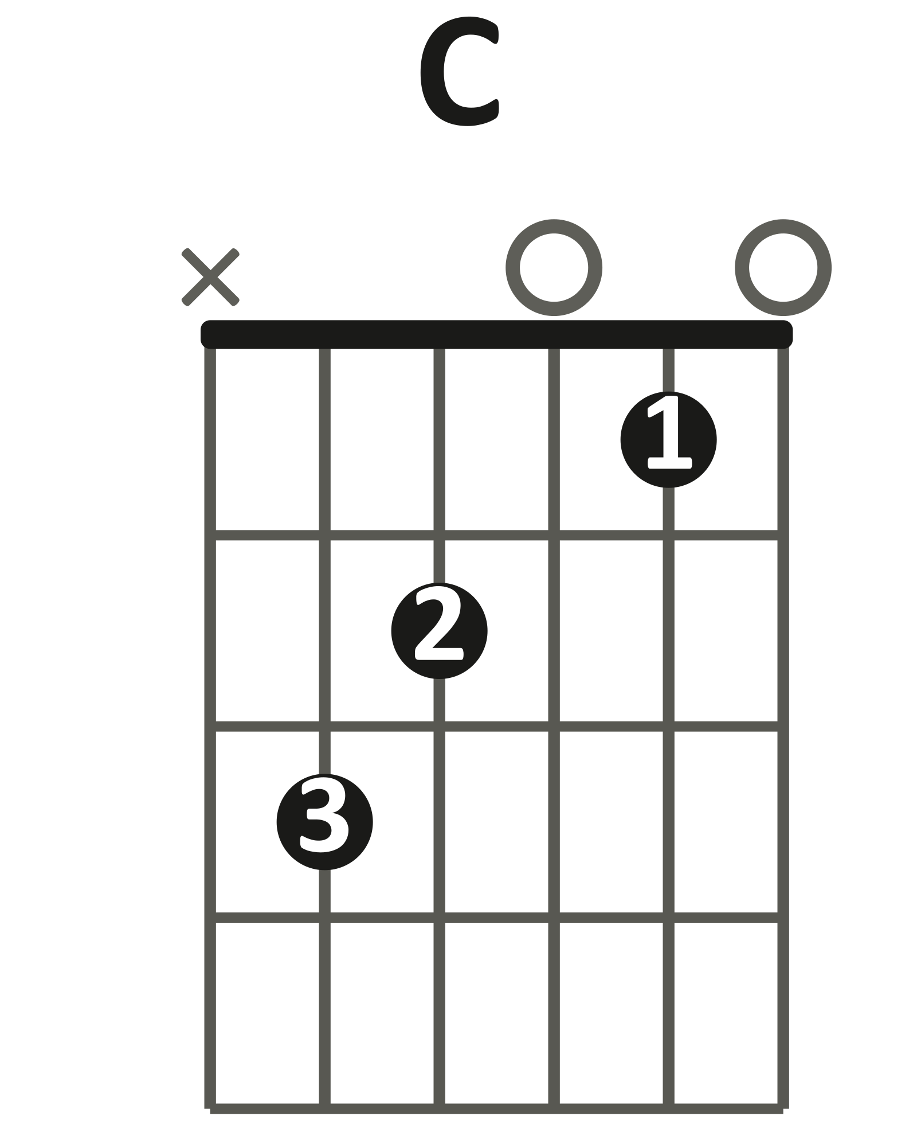 | 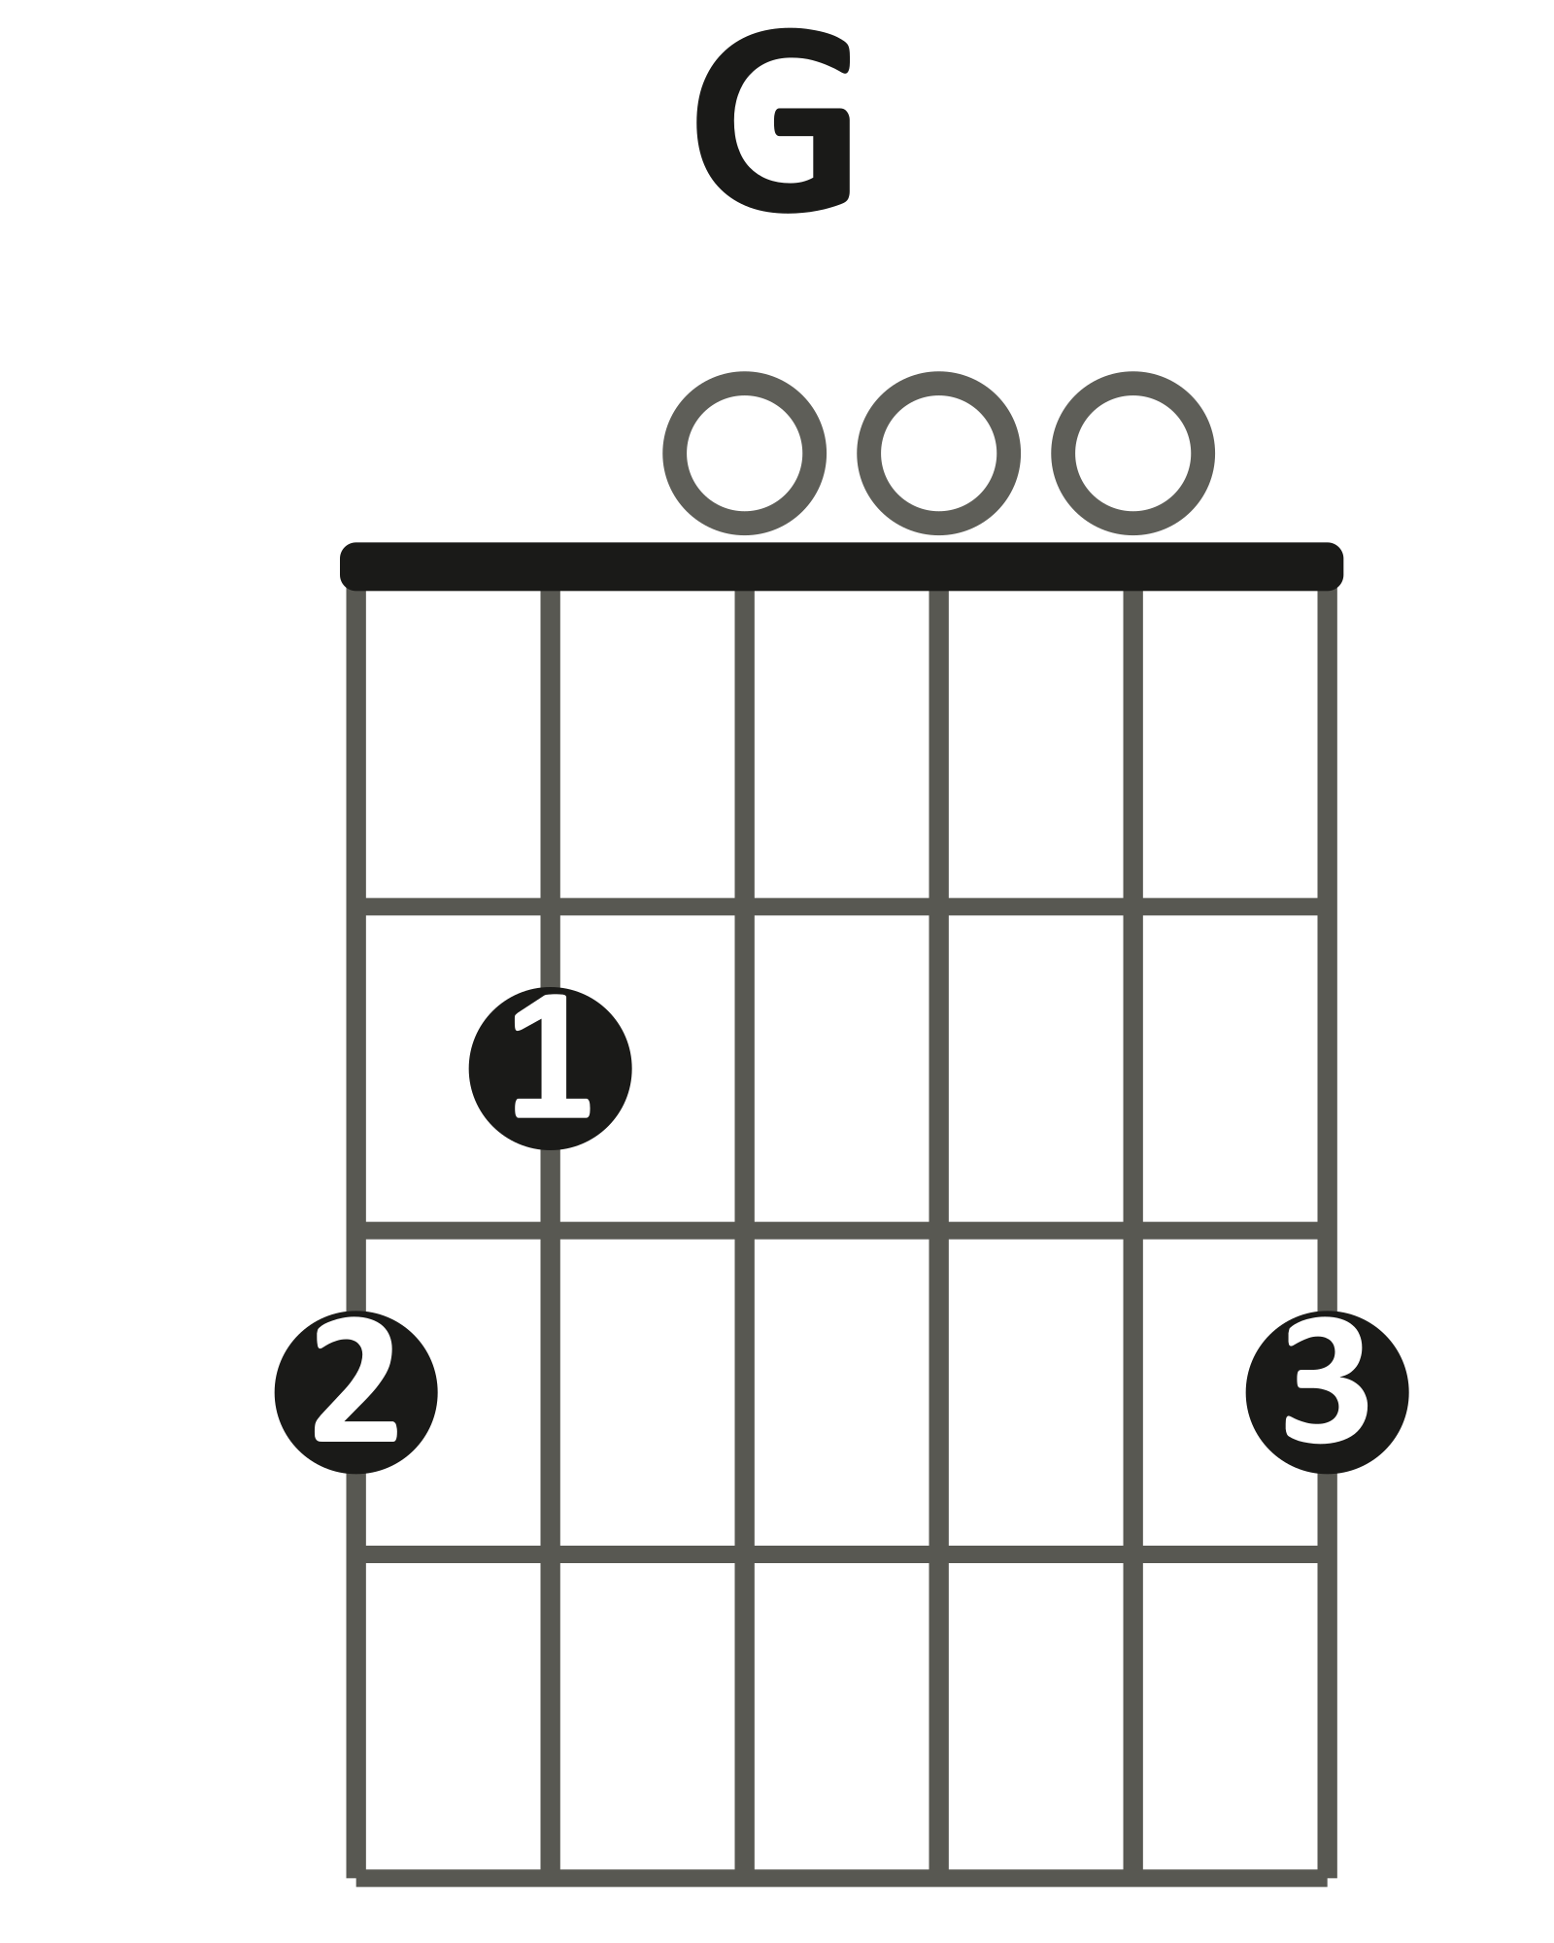 | 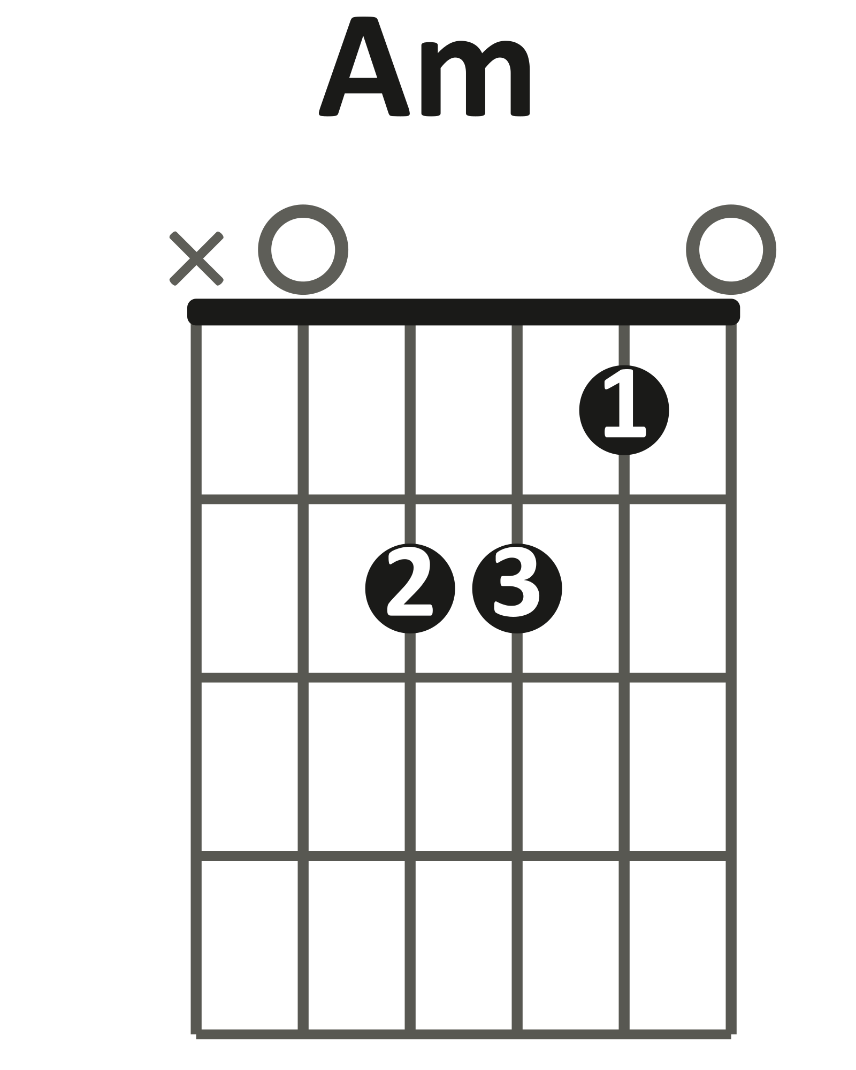 | 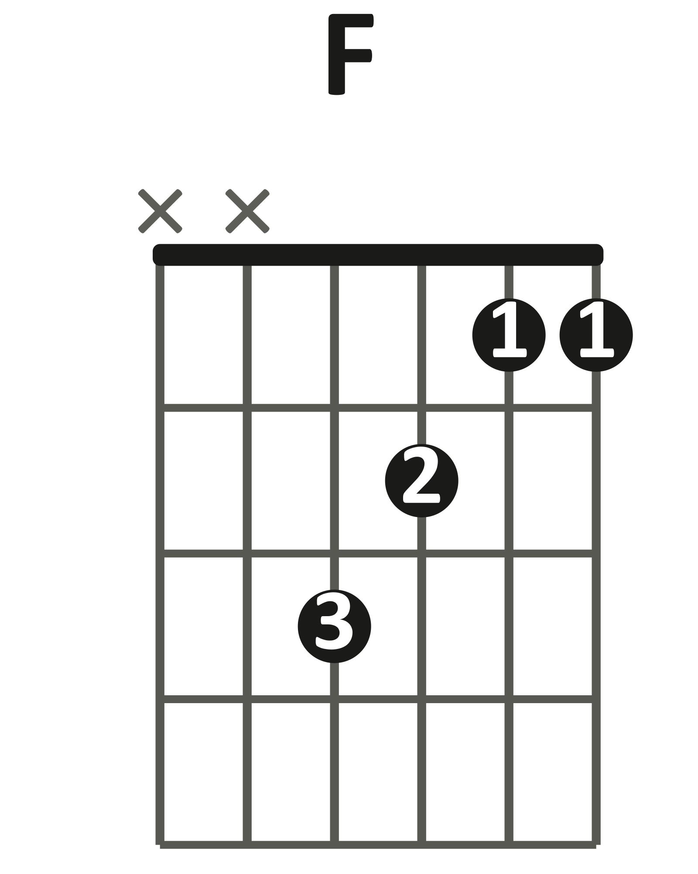  little shape (xx3211)

Verse loop · 4 beats per chord (practice tempo) · 60 BPM
| C | G | Am | F |
1 2 3 4 1 2 3 4 1 2 3 4 1 2 3 4

Play it: 1 down-strum per beat, 4 beats per chord.
One full verse loop, every change landing on beat 1.
Start forming the next chord on beat 4.
You've got it when: The full loop runs at 60 BPM with every change on the beat.
Level up
Once this feels easy, play it twice as fast: 2 beats per chord instead of 4.
That's the record's actual speed.
Level up · two beats per chord · verse
| C G | Am F |
1 2 3 4 1 2 3 4

LAYER 6 Fingerpicked Verse Bonus
Bonus layer. Optional harder challenge. No score.
Trade the strum for a soft 8-note roll, p-i-m-a-m-i-m-i, 2 notes per beat. Your thumb walks the bass note of each chord.
p = thumb · i = index · m = middle · a = ring. The thumb plays the bass note. The fingers stay on the G, B, and e strings.
thumb: A string, fret 3 | thumb: low E, fret 3 | thumb: open A | thumb: D string, fret 3

C arpeggio · p i m a m i m i · one bar
e |-----------0--------------|
B |--------1-----1-----1-----|
G |-----0-----------0-----0--|
D |--------------------------|
A |--3-----------------------|
E |--------------------------|

Play it: One bar of C, 2 notes per beat at 60 BPM.
p = A string fret 3 · i = open G · m = B string fret 1 · a = open e.
Then walk the verse — only the thumb changes strings.
The verse walk · thumb changes bass, one bar per chord · 60 BPM
C G
e |-----------0--------------|-----------3--------------|
B |--------1-----1-----1-----|--------0-----0-----0-----|
G |-----0-----------0-----0--|-----0-----------0-----0--|
D |--------------------------|--------------------------|
A |--3-----------------------|--------------------------|
E |--------------------------|--3-----------------------|

Am F
e |-----------0--------------|-----------1--------------|
B |--------1-----1-----1-----|--------1-----1-----1-----|
G |-----2-----------2-----2--|-----2-----------2-----2--|
D |--------------------------|--3-----------------------|
A |--0-----------------------|--------------------------|
E |--------------------------|--------------------------|

You've got it when: The verse loop C · G · Am · F runs at 60 BPM without stopping.
Level up
Play the same roll on the chorus chords. Thumb finds the new bass note.
Level up · the chorus roll · one bar per chord
Am G
e |-----------0--------------|-----------3--------------|
B |--------1-----1-----1-----|--------0-----0-----0-----|
G |-----2-----------2-----2--|-----0-----------0-----0--|
D |--------------------------|--------------------------|
A |--0-----------------------|--------------------------|
E |--------------------------|--3-----------------------|

F C
e |-----------1--------------|-----------0--------------|
B |--------1-----1-----1-----|--------1-----1-----1-----|
G |-----2-----------2-----2--|-----0-----------0-----0--|
D |--3-----------------------|--------------------------|
A |--------------------------|--3-----------------------|
E |--------------------------|--------------------------|

LAYER 7 The Solo Bonus
Bonus layer. Optional harder challenge. No score. Best once Layer 4's box feels automatic.
The solo is a simple melody. It rises, then falls back to C.
The solo · Pattern 1 box at fret 5 · one note per beat
C G Am F
G A G E E D C
e |-------5------------|--------------------|
B |--8---------8----5--|--5-----------------|
G |--------------------|-------7----5-------|
D |--------------------|--------------------|
A |--------------------|--------------------|
E |--------------------|--------------------|

Play it: 1 note per beat at 60 BPM, hand in 5th position.
Bar 1 rises: G (B string, fret 8), A (e string, fret 5), G, E (B string, fret 5).
Bar 2 falls: E, D (G string, fret 7), C (G string, fret 5) — hold C 2 beats.
You've got it when: The solo runs clean at 60 BPM, with the C held 2 full beats.
Level up
Fingerpick the verse, strum the chorus, then play this solo.
FULL CHORD CHART
"Let It Be"
The Beatles
Key C major
Tempo Practice at 60 BPM · the record feels like 71
Rhythm On the record: 2 beats per chord. Practice tempo: one bar per chord.
Form Verse loop → Chorus turnaround → back to the verse, all the way through
Shapes you need

VERSE
| C G | Am F |
The I–V–vi–IV loop. Repeat until the chorus. 2 beats per chord at record speed.
CHORUS
| Am G | F C |
The turnaround — a short chord move that leads back to the verse loop.
SOLO
| C | G | Am | F |
The chords keep going under the solo (Bonus layer: Pattern 1 box at fret 5).
Teaching chart — simplified to match the Journey layers, not a note-for-note transcription. Chord names are what the class plays in standard tuning.

